Student Grading and Attendance System

Lehman College – CIS 344
Professor Yanilda Peralta Ramos
Fall 2025

By Andrew Assoh, Mohammad Hasan, and Keith Mora

Table of Contents
- Project Plan
- Technical Details
- Database Design
- User Guide

1. Project Plan
Project Scope:
The Student Grading and Attendance System is a web-based platform that helps teachers efficiently manage student records, track attendance, and input grades. It integrates students, courses, teachers, and grades into a single MySQL database, enabling easy retrieval and report generation using SQL joins.
Objectives:
- Automate grading and attendance tracking for teachers.
- Maintain accurate and centralized student records.
- Provide secure login for both teachers and students.
- Generate reports to analyze student performance and attendance trends.
Initial Design:
- Frontend: HTML, CSS, JavaScript
- Backend: PHP for data handling and logic
- Database: MySQL (using multiple related tables and foreign keys)
- Tools Used: MySQL Workbench, XAMPP, and Visual Studio Code

2. Technical Details
The system is developed using PHP for backend logic and MySQL for database management, while HTML and CSSmanage the front-end layout. The application runs locally through XAMPP, which provides both the Apache server and MySQL environment.

Application Structure
The project follows a modular approach:
- Frontend: HTML and CSS handle all pages, including the login form, student dashboard, and teacher dashboard.
- Backend: PHP files process user inputs such as login credentials, attendance, and grades, and communicate with the database to store or retrieve information.
- Database: The MySQL schema student_grading_system manages all student, teacher, course, grade, and attendance records using linked relational tables.

Backend Functionality
- Teachers can log in, view their assigned courses, mark attendance, and record grades for students.
- Students can log in to view their individual grades and attendance records.
- Each main feature (login, attendance tracking, and grading) is handled by a dedicated PHP file, ensuring clarity and easier troubleshooting.
- Parameters are used in PHP scripts to organize data transfer between the web interface and the database efficiently.

Database Design and Communication
The database and web application communicate through a central connection file (db_connect.php), which allows all other PHP scripts to interact with the same database. The use of defined parameters and consistent variable handling helps prevent errors and maintain organized data flow throughout the system.

Example Query Functionality
The system can display a student’s grades, courses, and attendance by joining related tables such as students, courses, and grades. These joins allow teachers and students to view complete information on one page without redundant entries.

Security and Data Protection
The system validates and filters user inputs before interacting with the database. Basic checks ensure that empty or incorrect values are not processed. Role-based access (teacher, student, users) limits which users can access or modify specific data. This structure keeps the application consistent and prevents unauthorized changes.

3. Database Design
The database is built using MySQL Workbench, and the schema name is student_grading_system.
Tables and Relationships:
- Users: Manages system logins for teachers and students (username, password, teacher/student roles).
- Students: Stores student details (ID, name, email).
- Courses: Linked to users via teacher_id and id.
- Grades: Linked to students and courses via student_id and course_id.
- Attendance: Tracks daily student attendance per course.
Primary and Foreign Keys:
- student_id → in Grades
- course_id → in Grades
- teacher_id → in Courses
- student_id → in Attendance
- course_id → in Attendance

Constraints Used:
- NOT NULL for required fields
- ENUM for roles and attendance status
- AUTO_INCREMENT for IDs

Example of a Join Relationship:
Courses are linked to teachers using a one-to-many relationship between users and courses through teacher_id. The WHERE clause only selects users with the role of teacher. It uses the AS keyword to display the column name as teacher_name instead of username for clarity.

SELECT courses.course_name, users.username AS teacher_name
FROM courses
INNER JOIN users ON courses.teacher_id = users.id
WHERE users.role = 'teacher';

4. User Guide

This section explains how to operate the Student Grading and Attendance System, detailing the purpose of each file, how to run the system locally, and how teachers and students interact with it through their respective dashboards.
The project functions within XAMPP, using Apache as the local web server and MySQL as the database engine.
For Teachers:
- Log in using your credentials.
- Navigate to the Courses section.
- Record attendance or assign grades.
- View student performance summaries.
For Students:
- Log in using your username and password.
- View your grades and attendance history.
Here is a detailed breakdown of what each file does and how to use it:

db_connect.php
Purpose: Establishes a connection to the MySQL database (student_grading_system).
How to Run: Place inside /php/ folder and ensure MySQL is running.
Key Concepts: MySQL connection, error handling, reusable include file.
login.php
Purpose: Handles authentication for teachers and students.
How to Run: Submit credentials via index.html.
Key Concepts: Sessions, password_verify(), and role-based redirect.

logout.php
Purpose: Terminates user session and redirects to login page.
How to Run: Click Logout on either dashboard.
Key Concepts: session_destroy(), header redirection.
index.html
Purpose: Login form for all users.
How to Run: Access through http://localhost/student_grading_system/index.html.
Key Concepts: HTML form using POST method.
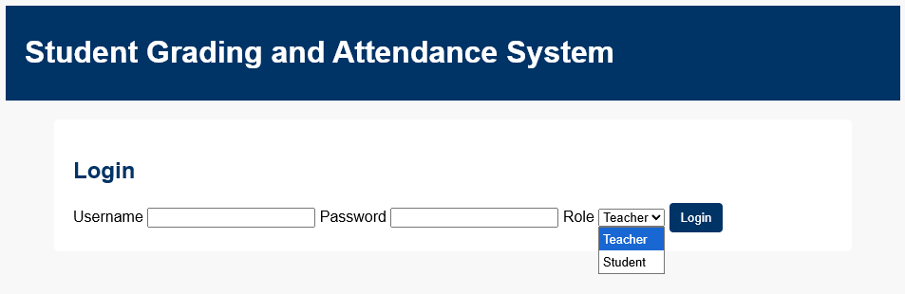
This interface allows users to log in by entering their username, password, and selecting their role (teacher or student). It provides secure access to the system’s dashboards.

Student_dashboard.html
Purpose: Displays a student’s grades and attendance.
How to Run: Log in as a student to view records.
Key Concepts: Static display, tables, and logout link.

Displays the student’s grades and attendance records. Data is dynamically retrieved from the database and displayed through structured tables.

teacher_dashboard.html
Purpose: Allows teachers to mark attendance and submit grades.
How to Run: Log in as a teacher to submit attendance and grades.
Key Concepts: HTML forms with arrays (status[] / grade[]), POST submission.
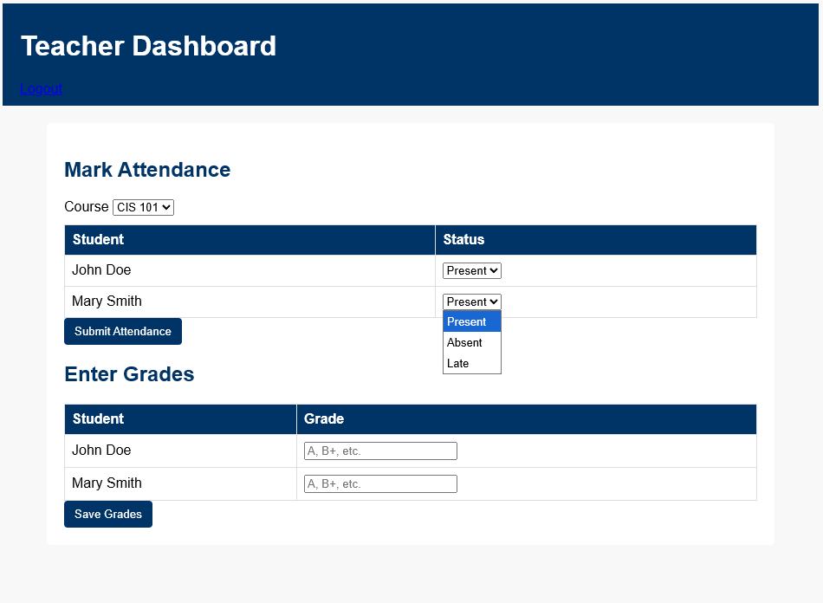
Allows teachers to mark attendance and record grades for each student. Submissions are processed through PHP forms linked to the database.

attendance.php
Purpose: Processes attendance data submitted by the teacher.
How to Run: Submit attendance form from the Teacher Dashboard.
Key Concepts: Loops through array data, inserts into the Attendance table with CURDATE().
grades.php
Purpose: Processes grades submitted by the teacher.
How to Run: Submit the grades form from the Teacher Dashboard.
Key Concepts: Prepared statements, data validation, and CURDATE() insertion.
student_grading_system.sql
Purpose: Creates database tables and relationships.
How to Run: Run in phpMyAdmin > SQL tab.
Key Concepts: CREATE DATABASE, FOREIGN KEYS, ENUM definitions.
student_grading_system_joins.sql
Purpose: Demonstrates SQL joins for reports.
How to Run: Import or run queries in phpMyAdmin.
Key Concepts: INNER JOIN between Students, Courses, Grades, and Attendance.
style.css
Purpose: Defines visual styling across all pages.
How to Run: Ensure the correct link path in the HTML files’ <head> elements: <link rel=“stylesheet” href=“style.css”>
Key Concepts: table/button design, hover effects.

XAMPP Control Panel
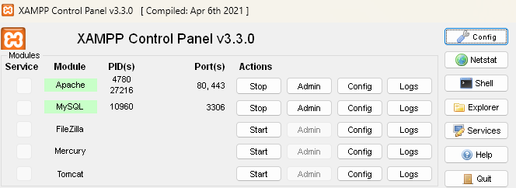
Shows the XAMPP Control Panel with Apache and MySQL modules active, confirming that the local web server and database are running.
Conclusion
This user guide explains how each file functions within the Student Grading and Attendance System. Teachers can record attendance and grades, while students can view their performance. The application operates locally through XAMPP and uses a modular PHP structure for easy updates.

